|  |
| --- |
| **SIDDHARTH GROUP OF INSTITUTIONS :: PUTTUR**  **(AUTONOMOUS)**  Siddharth Nagar, Narayanavanam Road – 517583  **QUESTION BANK (DESCRIPTIVE)**  **Subject with Code :**Basic Electrical Engineering(18EE0239)  **Course & Branch**: B.Tech–(ECE&CSE)  **Year & Sem:** I-B.Tech& II-Sem **Regulation:** R18 |

**UNIT –I**

**DC CIRCUITS**

1. (a)State and explain Kirchhoff’s laws? [L1][4M]

(b)Determine the current in branch A-B by using KVL [L4][6M]

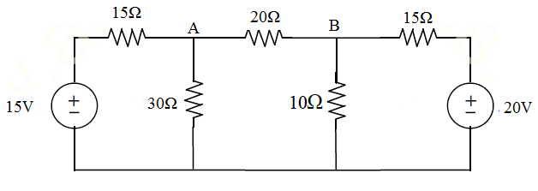

2. a) State and explain Norton’s theorem? [L1] [5M]

b) Draw the Norton’s equivalent circuit for the circuit shown in figure. [L4] [5M]

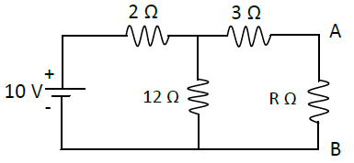

1. Determine the mesh currents for the circuit shown below. [L4] [10M]

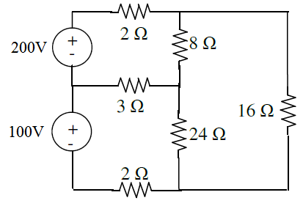

1. Use nodal analysis to find the node voltages for the below circuit. [L4] [10M]

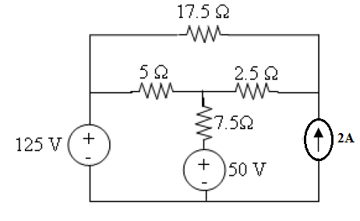

5. a) State and Explain Thevenin’s Theorem [L1] [5M]

b) Find load current by using Thevenin’s theorem for the following circuit where RL=3Ω [L4] [6M]

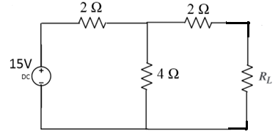

6 a)Derive the time response of RL circuit [L2] [5M]

b)find the Thevenin’s equivalent for the circuit shown below [L4] [5M]

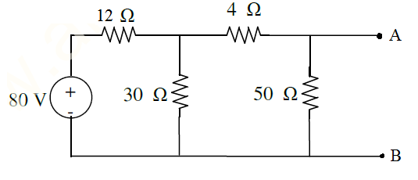

7. a) Derive the time response of RC circuit [L2] [5M]

b)find the Norton’s equivalent for the circuit shown below. [L4] [5M]

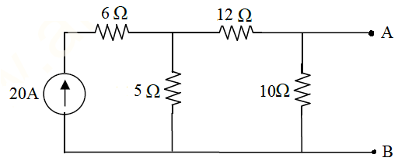

8.a) State and explain Superposition theorem? [L1] [4M]

b) Verify Superposition theorem for 4Ω resistor for the following circuit. [L4] [6M]

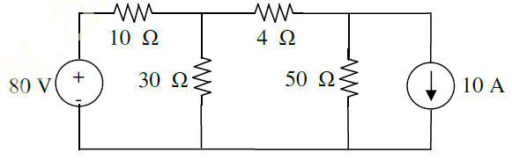

9. a) explain the circuit elements R,L &C. [L1] [4M]

b) i) Find the equivalent resistance between AB for the circuit shown bellow. [L3] [3M]

R1=4Ω, R2=2Ω, R3=8Ω, R4=1Ω, R5=12Ω, R6=3Ω, R7=10Ω & R8=5Ω

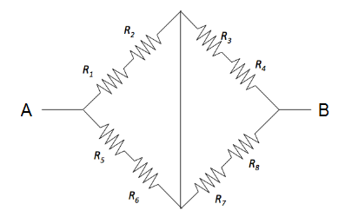

ii) Find the equivalent resistance for the circuit shown below. [L3] [3M]

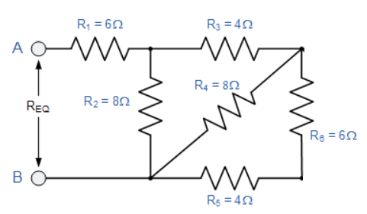

10. State and Expalin the Super position theorem. And By using superposition theorem find the current flowing through the 3 ohm resister. [L4] [10M]

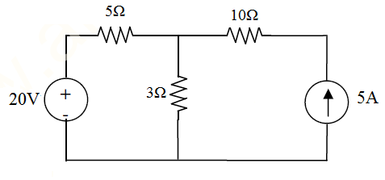

11.(a) What is Circuit and Network? [L1][2M]

(b) Define Inductance ? [L1][2M]

(c) Define Capacitor and represent symolically ? [L1][2M]

(d) State Ohm’s law and write its expression ? [L1][2M]

(e) A electric kettle takes a current of 12.5A at 240V. What is the resistance of heating [L1][2M]

Element ?

**UNIT-II**

**AC CIRCUITS**

1. (a) Derive an expression for RMS values of sine wave form. [L2][6M]

(b) An alternating current is expressed as I = 14.14 sin 314t. Determine. [L4][4M]

i. Maximum current ii. rms current iii. Frequency

iv. Instantaneous current when t = 0.02msec.

2. Derive an expression for the current and impedance for a series RL and RC circuit excited by a sinusoidally alternating voltage. Draw the phasor diagrams. [L3][10M]

3. a) Define Admittance and impedance [L1][4M]

b) The impedances of series circuit are Z1= (6+j8) ohms and Z2 = (8-j6) ohms. If the applied voltage is 120V, find total impedance, current and power factor. Draw the phasor diagram.[L2] [6M]

4. (a)Explain parallal RL and RC circuits with phasor diagrams. [L3][6M]

(b) A 120V AC circuit contain 10 Ω resistance and 30 Ω inductive reactance in series. What is average power of this circuit. [L2][4M]

5. (a) Define power factor, apparent power, active power and reactive power [L1] [4M]

(b) Z1 and Z2 are in parallel where currents corresponding impedances are I1 = 50∟10 and I2= 20∟30. If the applied voltage is 100∟15V, find true power, reactive power and apparent power in each branch. [L2] [6M]

6. a) Derive an expression for the voltage and impedance for a series RLC circuit excited by a sinusoidally alternating voltage. [L2] [5M]

(b) A series circuit consisting of a 10Ω resistor, a 100μF capacitor and a 10 mH inductor is driven by a 50 Hz a.c. voltage source of maximum value 100 volts. Calculate the equivalent impedance, Current in the circuit and the phase angle. [L2] [5M]

7. (a) Derive the voltage and current relations in three phase balanced circuits for delta connection.

[L2] [6M]

(b)Find the rms value for the following waveform [L3] [4M]

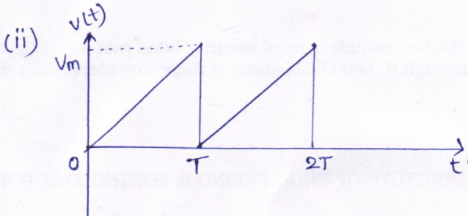

8. (a) Explain the phasor relation for R, L & C elements. [L1][4M]

(b) A resistor of 50Ω and inductance of 100mH are connected in series across 200V, 50Hz supply. Determine the following [L2] [6M]

(i) Impedance (ii) current flowing through the circuit (iii) power factor

9. (a) Derive the voltage and current relations in three phase balanced circuits for star connection.

[L2] [10M]

(b) Find the rms value for the following waveforms [L3] [4M]

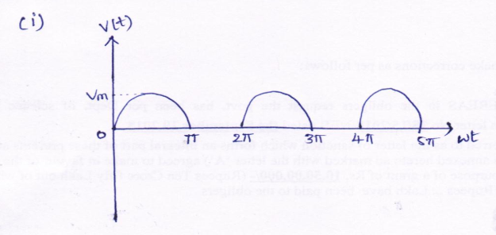

10. (a) Explain resonance for series RLC circuit and derive the equation for resonant frequency. [L2] [5M]

(b) A series RLC circuit of R=50 ohms, L= j25 ohms. Determine the value of capacitive reactance and impedance at resonance [L2] [5M]

11. (a) Define Form Factor and Peak Factor? [L1][2M]

(b) Define vector and phasor? [L1][2M]

(c) Define resonance? [L1][2M]

(d) Draw Star and Delta Connections of Three Phase circuit? [L1][2M]

(e) Write Expressions for Voltages and Current in Three Phase balanced [L1][2M]

system?

**Unit-III**

**TRANSFORMERS**

1.(a) Explain the briefly the construction and working of a single phase transformer [L2][6M]

(b) A 200 KVA, 1100/415V, 50Hz single phase transformer has 80 turns of secondary.

Calculate the primary number of turns. [L2][4M]

2.(a)Write a short notes on regulation and Efficiency of the transformer. [L1][5M]

(b)The efficiency of a 200 KVA,1-Ф transformer is 98.7% when operating at full-load,0.8 p.f lagging, the iron loss in the transformer is 200 W. Calculate: (i)Full load copper loss

(ii) Half load copper loss. [L3][5M]

3. (a)Explain the various losses in a transformer. [L1][5M]

(b) a single phase transformer with a ratio of 440/110V takes a no load current of 5A at 0.2 p.f. lagging. If the secondary supplies a current of 120A at a p.f. of 0.8 lagging.find the current taken by the primary. [L3] [5M]

4. (a) Explain BH characteristics. [L1] [5M]

(b) A 100KVA transformer has primary and secondary turns of 400 and 100 respectively. Its primary and secondary resistance and reactance are: R1=0.3Ω, R2=0.015Ω, X1=1.1Ω, X2=0.055Ω, supply voltage is 2400V.Calculate equivalent resistance and reactance on the primary side. [L2] [5M]

5. (a) Explain about magnetic materials. [L1] [4M]

(b) A 1-Ф,50 HZ transformer has 80 turns on the primary winding and 400 turns on the secondary winding. The net cross sectional area of the core is 200 cm2.If the primary winding is connected to a 240v,50 HZ supply, determine (i)The emf induced in the secondary winding.

(ii) The maximum value of the flux density in the core. [L2] [6M]

6.(a) Explain about ideal transformer and derive the EMF equation of the transformer. [L2] [6M]

(b) A 10KVA, 2200/220V, 50Hz single phase transformer has a net core area of 300cm2and a maximum flux density of 1.5wb/m2. Calculate the number of turns in primary and secondary winding. [L2] [6M]

7. Explain the practical transformer on load and draw the phasor diagrams. [L2][10M]

8. Obtain the equivalent circuit of single phase transformer referred to primary and secondary. [L2][10M]

9. What is meant by auto transformer? What are the advantages of Auto transformer when compared to two winding transformer? [L1] [10M]

10. What are three phase transformer connections and explain it? [L2][10M]

11. (a) Define Transformer? [L1][2M]

(b) Write Transformation ratio? [L1][2M]

(c) Why Transformer doesn’t work on DC? [L1][2M]

(d) Why Transformer rating will be in kVA? [L1][2M]

(e) What is the condition for maximum efficiency in a Transformer and [L1][2M]

expression for load current at maximum efficiency?

**Unit-IV**

**ELECTRICAL MACHINES**

1. What is rotating magnetic field? Explain in brief? [L2][10M]
2. Explain the construction of three phase induction motor? [L1][10M]
3. Sketch and explain the torque slip characteristics of 3 phase induction motor? [L2][10M]
4. Explain the construction of three phase alternator? [L1][10M]
5. Explain the construction single phase induction motor [L1][10M]
6. Explain the working principle of single phase induction motor [L2][10M]
7. Explain the construction of DC motor? [L1][10M]
8. Sketch and explain the torque speed characteristics of DC motor? [L2][10M]
9. Explain the various method of speed control of separately excited DC motor? [L2][10M]
10. Explain the working principle of synchronous generator? [L2][10M]
11. (a) Define Torque and slip? [L1][2M]

(b) Why is an induction motor called a rotating transformer?justify [L1][2M]

(c) why single phase induction motor is not self starting? [L1][2M]

(d) What is commutation & commutator? [L1][2M]

(e) Define Alternator ? [L1][2M]

**UNIT -V**

**ELECTRICAL INSTALLATIONS**

1. Explain different types of wiring system. [L2][10M]

2. Explain the following electrical wiring system with necessary diagrams.

(a) CTS wiring and (b) Concealed wiring [L2][10M]

3. With relevant diagrams explain in detail about various types of fuses used in electrical wiring systems. [L2][10M]

4. Explain briefly about earthing and how it plays an important role in installation. [L2][10M]

5. a) How many types of batteries are there? [L1][5M]

b) Explain the characteristics of batteries. [L2][5M]

6. Explain different methods used for improvement of power factor. [L2][10M]

7. a) Explain battery backup. [L1][5M]

b) How many types of cables are there? Explain them with neat sketch. [L1][5M]

8. What is energy consumption and Explain how it is calculated by an example. [L2][10M]

9. a) What is the importance of wiring. [L2][5M]

b) Explain how wiring system is classified. [L2][5M]

10. Explain about

a) pvc cables and b) wheather proof cables [L2][10M]

11. (a) Define Switch Gear? [L1][2M]

(b) Define Battery? [L1][2M]

(c) Define Energy and write it’s expression? [L1][2M]

(d) Define Fuse and Circuit Breaker? [L1][2M]

(e) What is Earthing? [L1][2M]